Coffee Shop Management

**Software Requirements Specification**

Version 1.0

Danang, Jan 2025

**TABLE OF CONTENTS**

**TABLE OF CONTENTS** 2

1. DOCUMENTARY HISTORY 4

2. REFERENCES 4

3. LIST OF PARTNERS AND TERMS 4

4. INTRODUCTION 4

4.1 Purpose 4

4.2 Scope 4

5. OVERVIEW 4

5.1 Actor 4

5.2 Use Case 4

5.3 System flow 4

6. FUNCTION DESCRIPTION 4

6.1 Login 4

6.2 CRUD beverage 4

6.3 Update table 4

6.4 Set table 4

6.5 Create bill 4

6.6 Update profile 4

6.7 View shift 4

6.8 View salary 4

6.9 CRUD staff 4

6.10 CRUD inventory 4

6.11 Export inventory data 4

6.12 View revenue 4

6.13 Export revenue data 4

6.14 CRUD voucher 4

7. NON-FUNCTIONAL REQUIREMENTS AND OTHER REQUIREMENTS 4

Efficiency 4

Security 5

Hardware 5

Internet 4

Reliability 5

User Interface 5

Scalability 5

8. APPENDIX 5

# Document history

| **Ngày** | **Sự thay đổi** | **Phiên bản** |
| --- | --- | --- |
|  |  |  |
|  |  |  |
|  |  |  |

# References

| **Tên tài liệu** | **Mô tả** |
| --- | --- |
|  |  |
|  |  |
|  |  |
|  |  |
|  |  |
|  |  |
|  |  |

# List of partners and terms

| **Tên** | **Tiêu đề** |
| --- | --- |
|  |  |
|  |  |
|  |  |
|  |  |
|  |  |
|  |  |
|  |  |
|  |  |
|  |  |

# Introduction

# Purpose

Software helps businesses achieve high efficiency: management becomes simpler, more accurate and faster.

The topic helps us approach a new form of implementing a specific project in the future.

# Scope

The software serves coffee shop management with functions applicable to a specific coffee shop. The system specifically describes the tasks that need to be done in a coffee shop model, which can perform the following tasks: employee management, warehouse management, sales management, facilities management or list management. menu books; In addition, there is also promotion management, revenue and expenditure management, statistical reporting, and data backup.

# Overview

## Actor

This software is designed to manage a coffee shop, with access restricted to two user roles: **Administrator** (acting as Manager) and **User Account** (acting as Sales Staff).

The **Administrator** has the ability to create and manage user accounts, while **User Accounts** are used by sales staff to perform specific tasks. Upon successful login, both roles gain access to the system, but their permissions differ:

* **Administrator**: Has full access to all system functions, including managing accounts, inventory, sales, and reports.
* **User Account**: Has limited access and is restricted to functions under the sales category and their personal account management.

This structured access ensures that administrators have complete control over operations while sales staff focus solely on relevant tasks.

| **Actor** | **Description** |
| --- | --- |
| Admin | Create a list of accounts, have access to all system functions. |
| Staff | Use accounts, perform sales management, manage personal accounts. |

## **Use Case diagram**

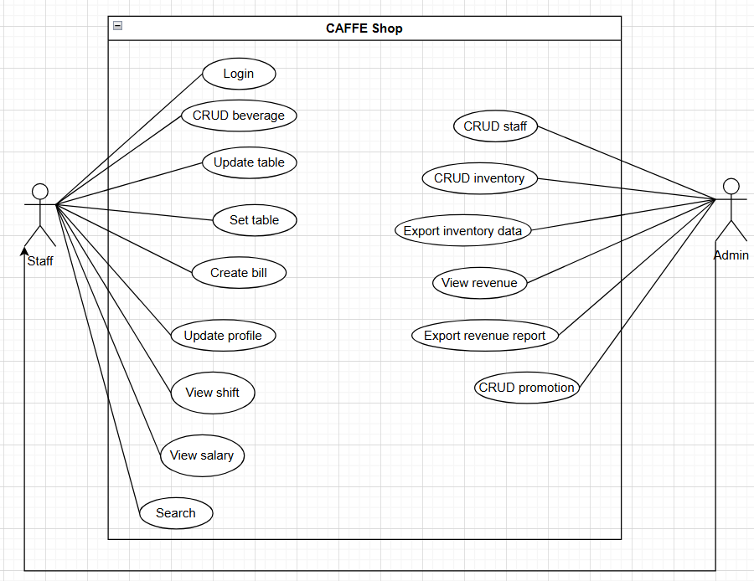

**Hình 5.2.1.** Use Case drawings of management and employee functions

## System flow

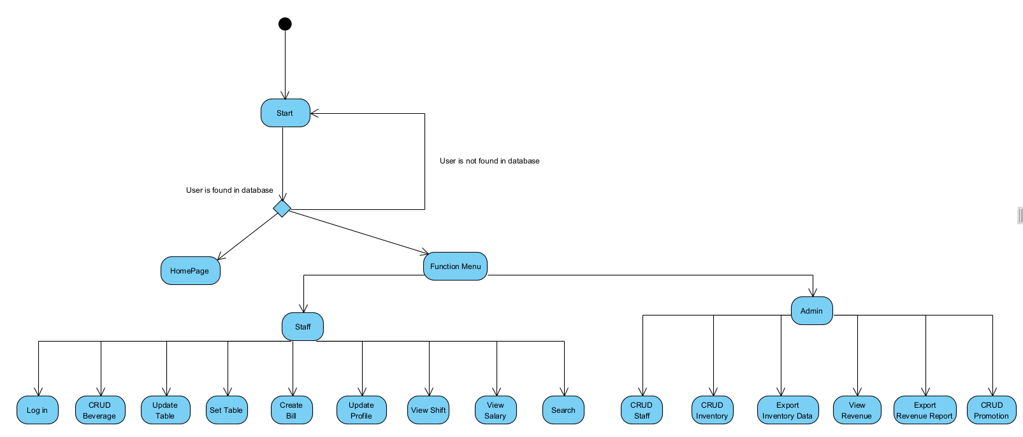

**Hình 5.3.1.** Sơ đồ luồng hệ thống

# **MÔ TẢ CHỨC NĂNG**

## Login

| Use Case Name | Login |
| --- | --- |
| Use Case ID | UC01 |
| High Level Requirement Ref | Users must log in to access system functions. |
| Actor | Manager and Staff |
| Description | Allows users to log in using credentials, including username and password. |
| Trigger | The user selects the **Login** function on the system interface. |
| Pre-condition | The user must have valid credentials issued by the system.  The user is not logged into the system. |
| Post-processing | If the login information is correct, the system redirects the user to the homepage and displays functions based on their role.  If the login information is incorrect, an error message is displayed, and the user is prompted to try again. |

### 

## CRUD Beverage

| Use Case Name | Main screescreen |
| --- | --- |
| Use Case ID | UC02 |
| High Level Requirement Ref | All the function show out |
| Actor | Admin, staff |
| Description | Actor choose function on the function board |
| Trigger | NA |
| Pre-condition | Actor before login |
| Post-processing | Actor login successfully |

### Beverage List

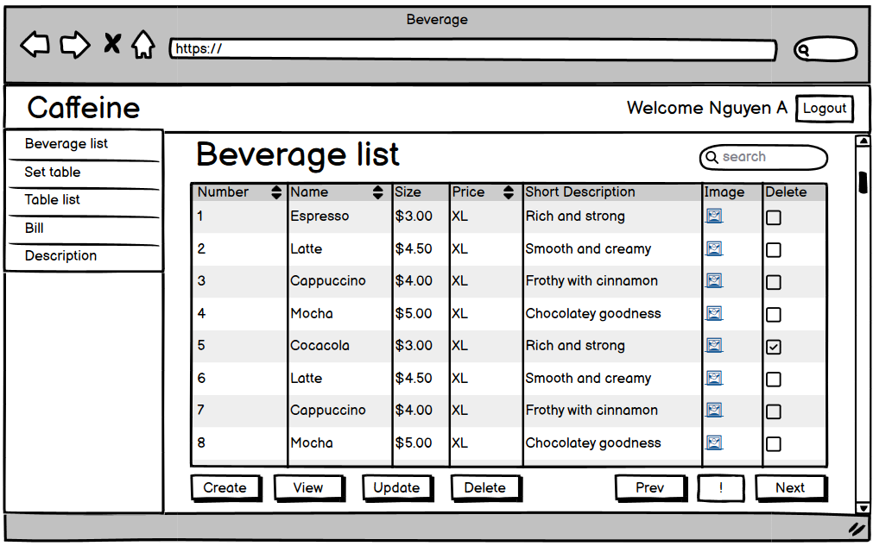

| **Screen** | Beverage List | | | | |
| --- | --- | --- | --- | --- | --- |
| **Description** | Displays a list of available beverages in the system. | | | | |
| **Screen Access** | Managers, Staff. | | | | |
| **Screen Content** | | | | | |
| **Item** | **Type** | **Data** | | **Description** | |
| Name | View | Beverage name | | View beverage name | |
| Size | View | Beverage size list | | View available size | |
| Price | View | Beverage price | | View price | |
| Short Description | View | Beverage short description | | View short description | |
| Image | View | Beverage image | | View image | |
| Number | View | Beverage number | | View number | |
| **Screen Actions** | | | | | |
| **Action Name** | **Description** | | **Success** | | **Failure** |
| Search bar | Search for a beverage in the list | | Display new list | | Error message |
| Create | Add a new beverage | | Ask to save change and display blank detail page | | Error message |
| View | Display detailed selected beverage | | Display detail of a drinks | | Error message |
| Update | Update beverage selected beverage | | Display detail of a drinks | | Error message |
| Delete | Remove selected beverage | | Show confirmation popup | | Error message |
| Previous page | To move to the previou list page | | Display new list | | Error message |
| Pagination box | To move to the specific list page | | Display new list | | Error message |
| Next page | To move to the next list page | | Display new list | | Error message |

### Beverage Detail

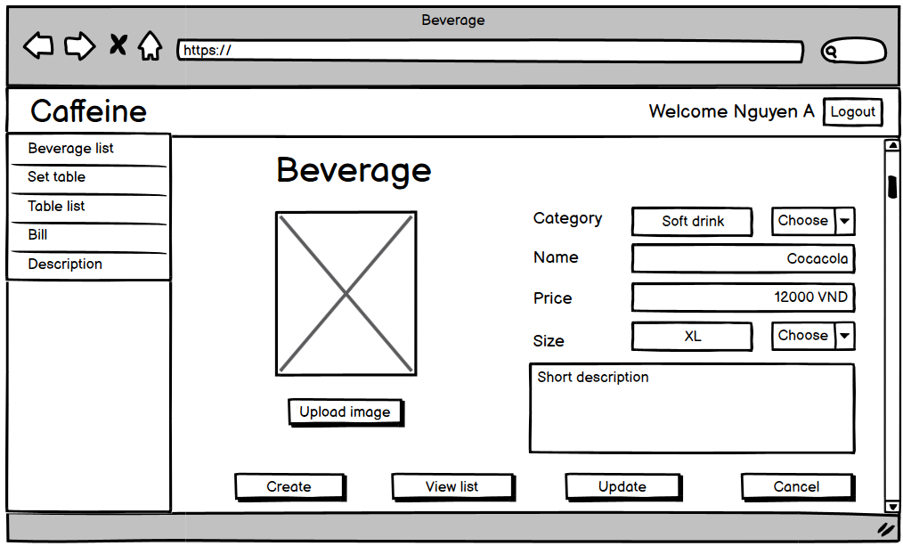

| **Screen** | Beverage Detail | | | | |
| --- | --- | --- | --- | --- | --- |
| **Description** | Displays detail of the selected beverage in the system. | | | | |
| **Screen Access** | Managers, Staff. | | | | |
| **Screen Content** | | | | | |
| **Item** | **Type** | **Data** | | **Description** | |
| Name | Text field | Beverage name | | Enter beverage name | |
| Size | Dropdown list | Beverage size list | | Choose size | |
| Price | Text field | Beverage price | | Enter price | |
| Short Description | Text field | Beverage short description | | Enter short description | |
| Image | File upload | Upload beverage image | | Display upload image | |
| Category | Dropdown list | Beverage category | | Choose category | |
| **Screen ActionsS** | | | | | |
| **Action Name** | **Description** | | **Success** | | **Failure** |
| Create | Move to blank beverage detail | | Display blank detail page | | Error message |
| View list | Display beverage list | | Display detail of a drinks | | Error message |
| Update | Update beverage selected beverage | | Display new detail | | Error message |
| Delete | Remove selected beverage | | Show confirmation form | | Error message |
| Upload image | Choose picture to upload | | Display new image | | Error message |

### 

### Create New Beverage

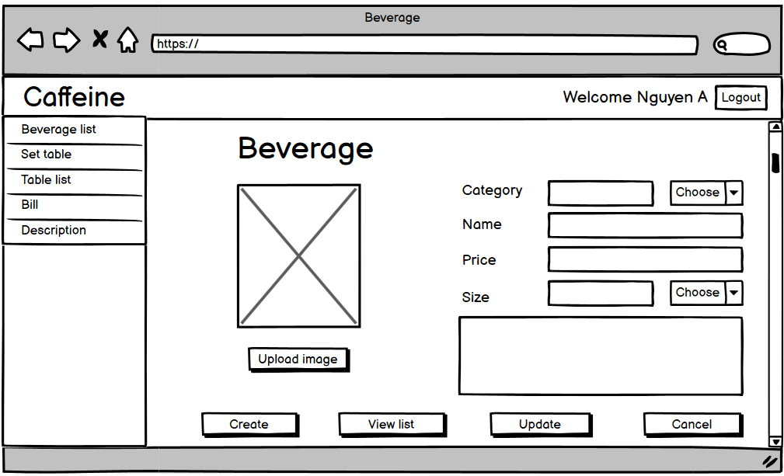

| **Screen** | Add new beverage | | | | |
| --- | --- | --- | --- | --- | --- |
| **Description** | Displays new blank details of a beverage in the system. | | | | |
| **Screen Access** | Managers, Staff. | | | | |
| **Screen Content** | | | | | |
| **Item** | **Type** | **Data** | | **Description** | |
| Name | Text field | Beverage name | | Enter beverage name | |
| Size | Dropdown list | Beverage size list | | Choose size | |
| Price | Text field | Beverage price | | Enter price | |
| Short Description | Text field | Beverage short description | | Enter short description | |
| Image | File upload | Upload beverage image | | Display upload image | |
| Category | Dropdown list | Beverage category | | Choose category | |
| **Screen ActionsS** | | | | | |
| **Action Name** | **Description** | | **Success** | | **Failure** |
| Create | Move to blank beverage detail | | Display blank detail page | | Error message |
| View list | Display beverage list | | Display detail of a drinks | | Error message |
| Update | Update beverage selected beverage | | Display new detail | | Error message |
| Delete | Remove selected beverage | | Show confirmation form | | Error message |
| Upload image | Choose picture to upload | | Display new image | | Error message |

## CRUD Table

| Use Case Name | Set Table |
| --- | --- |
| Use Case ID | UC03 |
| High Level Requirement Ref | Show all the functions to edit table and using table |
| Actor | Staff, Admin |
| Description | Allow staff or admin to set, edit table |
| Trigger | NA |
| Pre-condition | Staff login success |
| Post-processing |  |

### Set Table/ Edit Table

## 

| **Screen** | Set table | | | | |
| --- | --- | --- | --- | --- | --- |
| **Description** | Displays a list of tables and functions to table in the system. | | | | |
| **Screen Access** | Managers, Staff. | | | | |
| **Screen Content** | | | | | |
| **Item** | **Type** | **Data** | | **Description** | |
| Number | View | Table number | | View table number | |
| Name | View | Table name | | View table name | |
| Seats | View | Table capacity | | View table maximum capacity | |
| Status | View | Table status | | Table status cleaning/available/In use | |
| Area | View | Table place | | View table place, area | |
| **Screen Actions** | | | | | |
| **Action Name** | **Description** | | **Success** | | **Failure** |
| View list table | View list table page | | Move to view list table page | | Error message |
| Update table | Show popup to update detail table | | Display details popup to input | | Error message |
| Delete table | Delete 1 or many table | | Display popup to confirm | | Error message |
| Create table | Create blank popup | | Show blank details popup | | Error message |

### 

* + 1. Table list

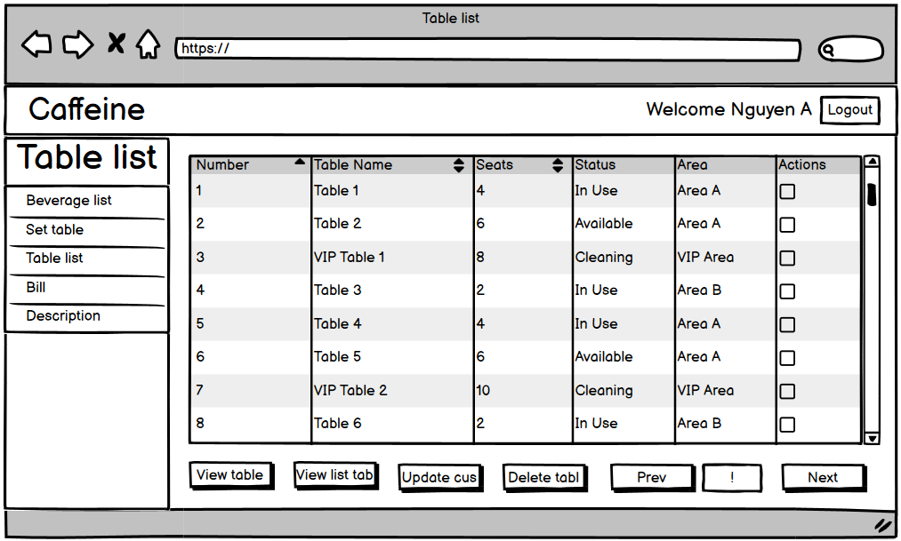

| **Screen** | Table List | | | | |
| --- | --- | --- | --- | --- | --- |
| **Description** | Displays a list of tables in the system. | | | | |
| **Screen Access** | Managers, Staff. | | | | |
| **Screen Content** | | | | | |
| **Item** | **Type** | **Data** | | **Description** | |
| Number | View | Table number | | View table number | |
| Name | View | Table name | | View table name | |
| Seats | View | Table capacity | | View table maximum capacity | |
| Status | View | Table status | | Table status cleaning/available/In use | |
| Area | View | Table place | | View table place, area | |
| **Screen Actions** | | | | | |
| **Action Name** | **Description** | | **Success** | | **Failure** |
| View detail | View detail of selected table | | Display detail of selected table | | Error message |
| Update table | Update detail of selected table | | Display detail of selected table | | Error message |
| Clean table | Wipe out detail of selected table | | Reset table to available | | Error message |
| Bill exportation | Export bill of selected table | | Move to bill export page | | Error message |
| Previous page | To move to the previou table list | | Display new table list | | No change |
| Pagination box | To move to the specific table list | | Display new table list | | No change |
| Next page | To move to the next table list | | Display new table list | | No change |

### Table Details

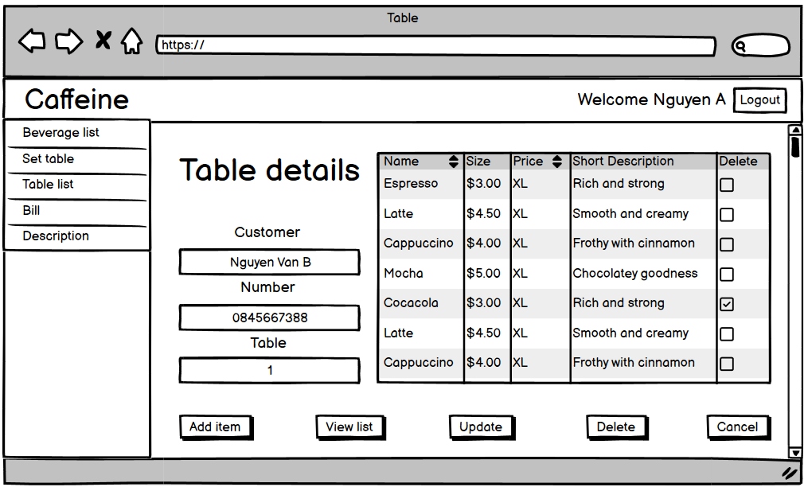

| **Screen** | Table details | | | | |
| --- | --- | --- | --- | --- | --- |
| **Description** | Displays details of a table in the system. | | | | |
| **Screen Access** | Managers, Staff. | | | | |
| **Screen Content** | | | | | |
| **Item** | **Type** | **Data** | | **Description** | |
| Name | Text field | Beverage name | | Enter beverage name | |
| Size | Dropdown list | Beverage size list | | Choose size | |
| Price | Text field | Beverage price | | Enter price | |
| Short Description | Text field | Beverage short description | | Enter short description | |
| **Screen Actions** | | | | | |
| **Action Name** | **Description** | | **Success** | | **Failure** |
| Add item | Add new item/beverage to ttable | | Move to add item page | | Error message |
| View list | Return to view list page | | Return to view list page | | Error message |
| Update table | Update customer detail of selected table | | Show confirmation message | | Error message |
| Delete item | Delete selected item from table | | Show confirmation message | | Error message |
| Cacel | Return to view list page, no change made | | Return to view list page | | Error message |

### Add Item To Table

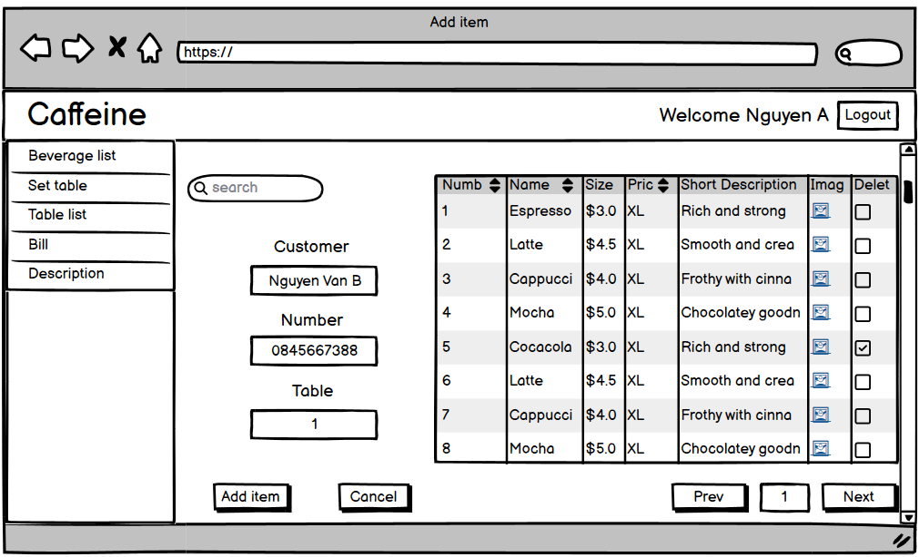

| **Screen** | Add item to selected table | | | | |
| --- | --- | --- | --- | --- | --- |
| **Description** | Displays a list of beverages in the system. | | | | |
| **Screen Access** | Managers, Staff. | | | | |
| **Screen Content** | | | | | |
| **Item** | **Type** | **Data** | | **Description** | |
| Customer | View | Customer name | | View customer name | |
| Number | View | Customer number | | View customer number | |
| Table | View | Table customer use | | View customer table | |
| Name | View | Beverage name | | View beverage name | |
| Size | View | Beverage size list | | View beverage size | |
| Price | View | Beverage price | | View beverage price | |
| Short Description | View | Beverage short description | | View beverage short description | |
| **Screen Actions** | | | | | |
| **Action Name** | **Description** | | **Success** | | **Failure** |
| Search | Input name to search beverage | | Show new list | | No change made |
| Add item | Add new item/beverage to table | | Return success message | | Error message |
| Cacel | Return to view list page, no change made | | Return to table list page | | Error message |

### Update Table Information

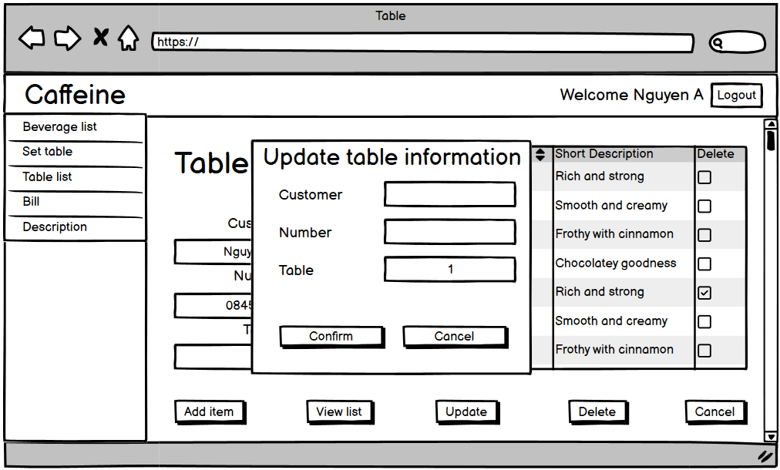

| **Screen** | Update customer information | | | | |
| --- | --- | --- | --- | --- | --- |
| **Description** | Displays a popup to input new information in the system. | | | | |
| **Screen Access** | Managers, Staff. | | | | |
| **Screen Content** | | | | | |
| **Item** | **Type** | **Data** | | **Description** | |
| Customer | Text field | Customer name | | Input customer name | |
| Number | Text field | Customer number | | Input customer number | |
| Table | View | Table customer use | | View customer table | |
| **Screen Actions** | | | | | |
| **Action Name** | **Description** | | **Success** | | **Failure** |
| Confirm | Click to save changes | | Return to table list page | | Error message |
| Cacel | Return to view list page, no change made | | Return to table list page | | Error message |

### 

## Create Bill

| Use Case Name | Create Bill |
| --- | --- |
| Use Case ID | UC04 |
| High Level Requirement Ref | User confirm to export bill |
| Actor | Staff |
| Description | User go through action to confirm and show out information of a bill |
| Trigger | NA |
| Pre-condition | Staff export bill from a in use table |
| Post-processing |  |

### Export Bill From A Table

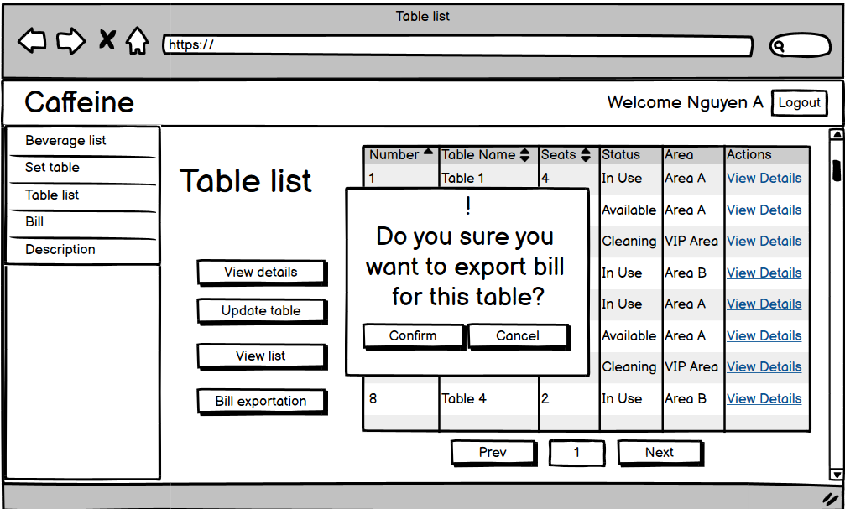

| **Description** | Displays a popup to confirm the export bill in the system. | | | | |
| --- | --- | --- | --- | --- | --- |
| **Screen Access** | Managers, Staff. | | | | |
| **Screen Content** | | | | | |
| **Item** | **Type** | **Data** | | **Description** | |
| Popup | View | Text | | Notification ready to export | |
|  |  |  | |  | |
|  |  |  | |  | |
| **Screen Actions** | | | | | |
| **Action Name** | **Description** | | **Success** | | **Failure** |
| Confirm | Click to confirm | | Go to bill check page | | Error message |
| Cacel | Return to view list page, no change made | | Return to table list page | | Error message |

### Bill Check

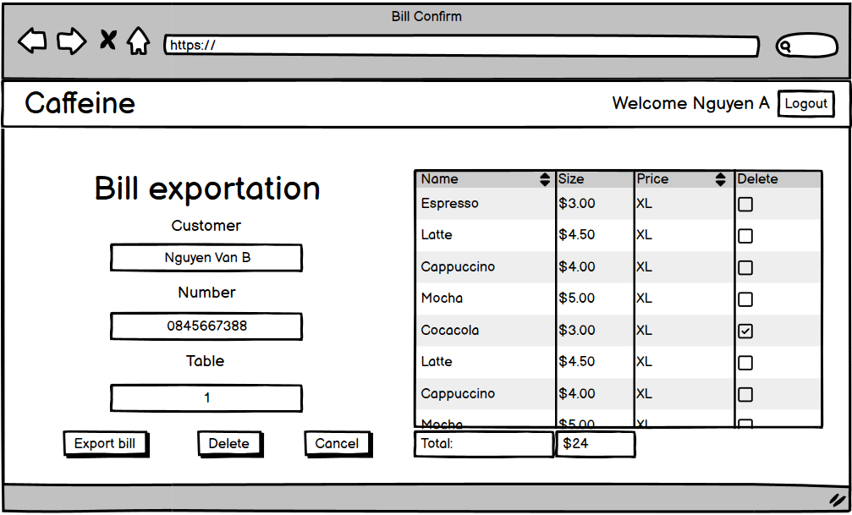

| **Description** | Displays review bin the system. | | | | |
| --- | --- | --- | --- | --- | --- |
| **Screen Access** | Managers, Staff. | | | | |
| **Screen Content** | | | | | |
| **Item** | **Type** | **Data** | | **Description** | |
| Customer | Text field | Customer name | | Input customer name | |
| Number | Text field | Customer number | | Input customer number | |
| Table | View | Table customer use | | View customer table | |
| Name | View | Beverage name | | View beverage name | |
| Size | View | Beverage size list | | View beverage size | |
| Price | View | Beverage price | | View beverage price | |
| **Screen Actions** | | | | | |
| **Action Name** | **Description** | | **Success** | | **Failure** |
| Export bill | Click to confirm export bill | | Go to payment page | | Error message |
| Delete item | Delete selected item from table | | Show confirmation message | | Error message |
| Cacel | Return to view list page, no change made | | Return to table list page | | Error message |

### Payment Page

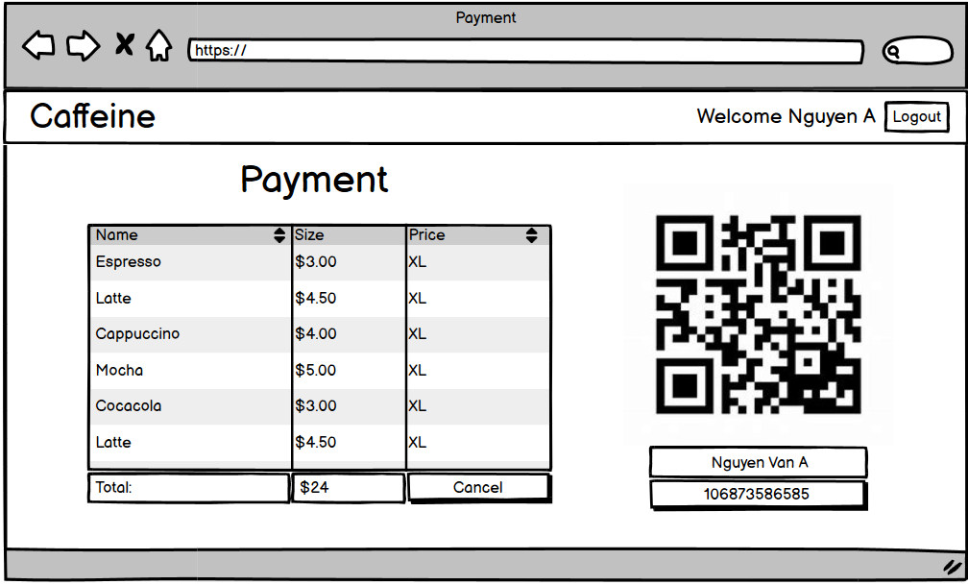

| **Description** | Displays payment page in the system. | | | | |
| --- | --- | --- | --- | --- | --- |
| **Screen Access** | Managers, Staff. | | | | |
| **Screen Content** | | | | | |
| **Item** | **Type** | **Data** | | **Description** | |
| Name | View | Beverage name | | View beverage name | |
| Size | View | Beverage size list | | View beverage size | |
| Price | View | Beverage price | | View beverage price | |
| **Screen Actions** | | | | | |
| **Action Name** | **Description** | | **Success** | | **Failure** |
| Cacel | Return to view list page, no change made | | Return to review page | | Error message |

### 

## 

## Update Profile

| Use Case Name | Update Profile |
| --- | --- |
| Use Case ID | UC05 |
| High Level Requirement Ref | Allows staff to update their own profile details within the system. |
| Actor | Staff |
| Description | Staff members can perform the following actions on their personal profile:   * View their current profile information (e.g., name, contact details, role). * Update editable fields such as name, gender, Date of Birth, address, phone number and email. |
| Trigger | The staff member accesses the "Profile" section from their account menu. |
| Pre-condition | The staff member is logged into the system with valid credentials.  The system must display the profile interface with current data populated. |
| Post-processing | - Changes to editable fields are saved in the system immediately.  - A notification is sent confirming the successful update or submission for approval. |

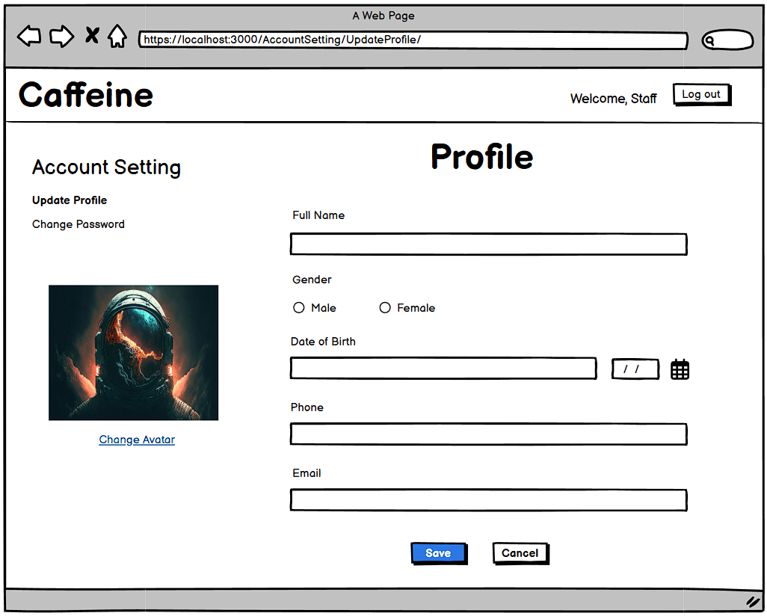

| **Screen** | Update profile | | | | |
| --- | --- | --- | --- | --- | --- |
| **Description** | | Allows staff to update their own profile details within the system. | | | |
| **Screen Access** | | Navigate to: ***Account setting -> Update profile*** | | | |
| **Screen Content** | | | | | |
| **Item** | | **Type** | **Data** | **Description** | |
| Full Name | | Text field – String (50) | Input by the staff | Enter the full name of the staff member. | |
| Gender | | Dropdown – String (Male/Female/Other) | Input by the staff | Choose the staff member’s gender. | |
| Date of Birth | | Date | Input by the staff | Select the staff member’s date of birth. | |
| Phone Number | | Text field – String (15) | Input by the staff | Enter the staff member’s contact number. | |
| Email | | Text field – String (50) | Input by the staff | Enter the staff member’s email. | |
| Address | | Text field – String (100) | Input by the staff | Enter the staff member’s address. | |
| **Screen Actions** | | | | | |
| **Action Name** | | **Description** | | **Success** | **Failure** |
| Save | | Saves the update staff details to the system database. | | Displays a success message: "Saved successfully." | Shows an error message highlighting invalid or missing fields. |

## View Shift

| Use Case Name | View Shift |
| --- | --- |
| Use Case ID | UC06 |
| High Level Requirement Ref | Allows the staff member to view their shift schedule and send shift registration requests to the admin. |
| Actor | Staff |
| Description | The staff member can perform the following actions related to shift management:   * View their current and upcoming shift schedule, including assigned shift and times. * Select a preferred shift and specify the desired time. * Submit a request to register for the selected shift, which is sent to the administrator for approval. |
| Trigger | The staff accesses the shift management menu and selects "Request Shift." |
| Pre-condition | The staff is logged into the system with valid credentials.  The system displays the available shift options and their respective details. |
| Post-processing | - The shift request is successfully submitted to the admin.  - The system notifies the staff member of the submission status (e.g., "Shift request sent successfully").  - The administrator receives the shift request for review and approval. |

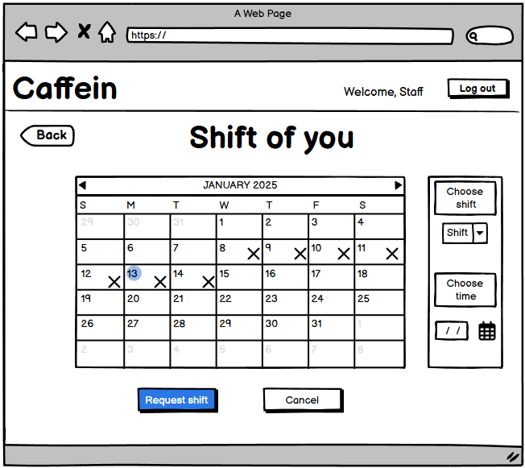

| **Screen** | Shift management - View shift | | | | |
| --- | --- | --- | --- | --- | --- |
| **Description** | | Allows the staff member to view their shift schedule and send shift registration requests to the admin. | | | |
| **Screen Access** | | Navigate to:  ***Shift Management -> View Shift*** | | | |
| **Screen Content** | | | | | |
| **Item** | | **Type** | **Data** | **Description** | |
| Choose Shift | | ComboBox | - Input by the staff | Select the shift which staff want to request. | |
| Choose Time | | DateTime | - Input by the staff | Select the time which staff want to request. | |
| Choose Date | | Date | - Input by the staff | Select the date which staff want to request. | |
| **Screen Actions** | | | | | |
| **Action Name** | | **Description** | | **Success** | **Failure** |
| Request shift | | Request the shift to the admin and wait approval. | | Displays a success message: "Request successfully." | Shows an error message highlighting invalid or missing fields. |

### 

## View Salary

| Use Case Name | View Salary |
| --- | --- |
| Use Case ID | UC07 |
| High Level Requirement Ref | Allows the staff to view their salary details within the system. |
| Actor | Staff |
| Description | The staff member can perform the following actions related to their salary:   * View their monthly salary details, including total of shift, total of hour, and total of salary. * View details of any performance bonuses or penalties. |
| Trigger | The staff accesses the salary management menu from their profile page. |
| Pre-condition | The staff is logged into the system with valid credentials.  The system has salary records for the staff stored in the database. |
| Post-processing | - The requested salary details are displayed accurately and completely.  - The system ensures that sensitive salary information is only accessible by the staff member associated with the account.  - A notification or confirmation is provided for successful retrieval of salary details (e.g., "Salary details loaded successfully"). |

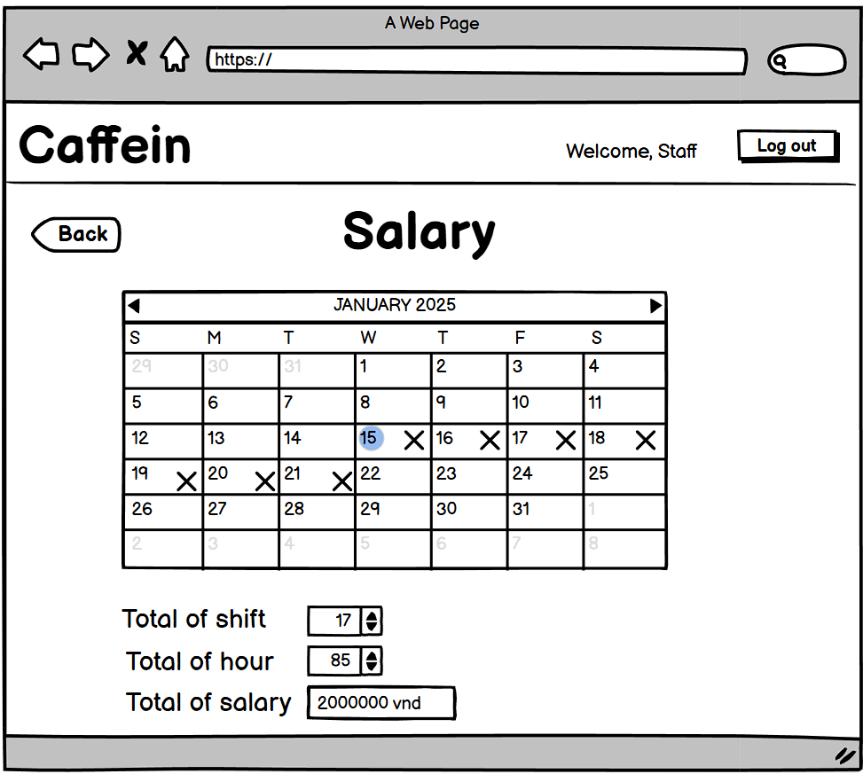

| **Screen** | Salary management - View salary | | | | |
| --- | --- | --- | --- | --- | --- |
| **Description** | | Allows the staff to view their salary details within the system. | | | |
| **Screen Access** | | Navigate to:  ***Salary Management -> View Salary*** | | | |
| **Screen Content** | | | | | |
| **Item** | | **Type** | **Data** | **Description** | |
| Total of shift | | Text Field – Number | - Loaded from database | Displays the total of shift the employee has worked | |
| Total of hour | | Text Field – Number | - Loaded from database | Displays the total of hour the employee has worked | |
| Total of salary | | Text Field – Number | - Loaded from database | Displays the total of salary the employee has recieve | |
| **Screen Actions** | | | | | |
| **Action Name** | | **Description** | | **Success** | **Failure** |
| Back | | Returns to the main screen. | | Redirects back to the main screen. | N/A |

### 

## CRUD Staff

| Use Case Name | **CRUD Staff** |
| --- | --- |
| Use Case ID | UC08 |
| High Level Requirement Ref | Allows the manager to perform CRUD (Create, Read, Update, Delete) operations on staff records within the system. |
| Actor | Manager |
| Description | The manager can perform the following actions on staff records:   * **View** a list of staff and detailed profiles. * **Add** new staff members by entering required details (e.g., name, role, salary, etc.). * **Update** staff details to reflect changes. * **Delete** staff records if they are no longer part of the team. |
| Trigger | The manager accesses the staff management menu. |
| Pre-condition | The manager is logged into the system with the proper credentials and permissions.  The system must display the staff management interface. |
| Post-processing | Changes to staff records are successfully saved in the system.  The updated list reflects changes immediately.  Notification or confirmation is provided for each action (e.g., "Staff added successfully"). |

### Add Staff

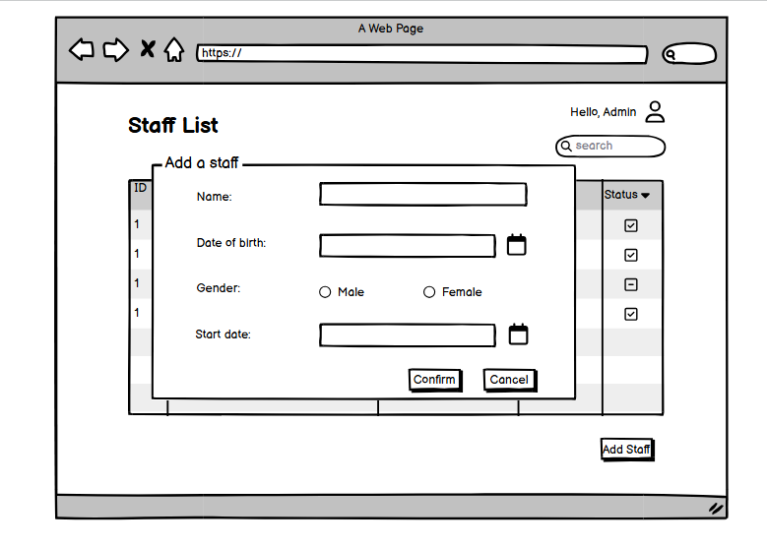

| **Screen** | Staff Management - Add New Staff | | | |
| --- | --- | --- | --- | --- |
| **Description** | Allows the manager to add new staff members by entering details such as name, date of birth, gender, role, and other relevant information. | | | |
| **Screen Access** | Navigate to **Staff Management -> Add New Staff** | | | |
| **Screen Content** | | | | |
| **Item** | **Type** | **Data** | **Description** | |
| Staff Name | Text field – String (50) | Input by the manager | Enter the full name of the staff member. | |
| Date of Birth | Date | Input by the manager | Select the staff member’s date of birth. | |
| Gender | Dropdown – String (Male/Female/Other) | Input by the manager | Choose the staff member’s gender. | |
| Phone Number | Text field – String (15) | Input by the manager | Enter the staff member’s contact number. | |
| Address | Text field – String (100) | Input by the manager | Enter the staff member’s address. | |
| Salary | Text field – Number (10) | Input by the manager | Enter the salary for the staff member. | |
| Status | Dropdown – String (Active/Inactive) | Input by the manager | Choose the current employment status. | |
| **Screen Actions** | | | | |
| **Action Name** | **Description** | | **Success** | **Failure** |
| Save Staff | Saves the entered staff details to the system database. | | Displays a success message: "Staff added successfully." | Shows an error message highlighting invalid or missing fields. |
| Clear Form | Clears all input fields to reset the form. | | The form is cleared successfully. | NA |
| Cancel | Cancels the operation and navigates back to the staff list. | | Redirects to the staff list screen. | NA |

### View Staff

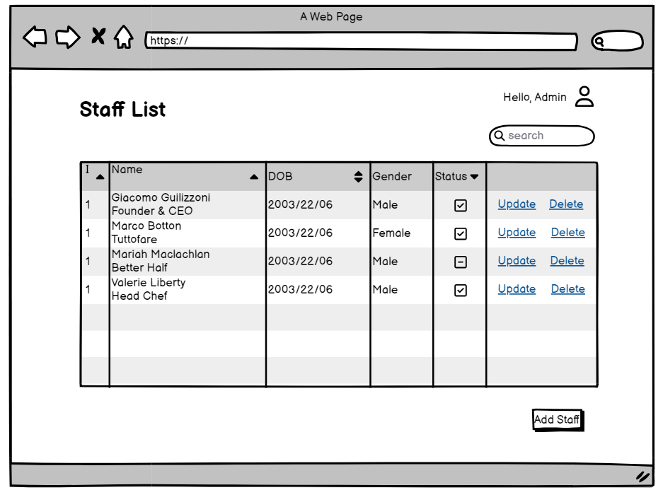

| **Screen** | Staff Management - View Staff | | | | |
| --- | --- | --- | --- | --- | --- |
| **Description** | Allows the manager to view a list of all staff members with their essential details. The manager can also filter, search, or sort the list and select an individual staff member for more detailed information. | | | | |
| **Screen Access** | Navigate to **Staff Management -> View Staff** | | | | |
| **Screen Content** | | | | | |
| **Item** | **Type** | **Data** | | **Description** | |
| Staff Name | Text field – String (50) | Data retrieved from the database | | The name of the staff member displayed in a list format. | |
| Gender | Text | Data retrieved from the database | | Displays the staff member’s gender (Male/Female/Other). | |
| Date of Birth | Date | Data retrieved from the database | | Displays the staff member's date of birth. | |
| Phone Number | Text field – Number (3) | Data retrieved from the database | | Shows the staff member's contact number | |
| Address | Button | Data retrieved from the database | | Shows the address of the staff member. | |
| Status | Button | Data retrieved from the database | | Indicates whether the staff member is Active or Inactive. | |
| **Screen Actions** | | | | | |
| **Action Name** | **Description** | | **Success** | | **Failure** |
| View Details | Displays all details for the selected staff member. | | Opens a detailed view page for the selected staff. | | NA |
| Delete Staff | Removes the selected staff member from the database. | | Displays confirmation: "Staff deleted successfully." | | Error: "Unable to delete staff, dependent records exist." |
| Edit Staff | Allows the manager to edit details of the selected staff. | | Opens the edit staff form for modifications. | | Error: "Unable to load staff details for editing." |

### Update Staff

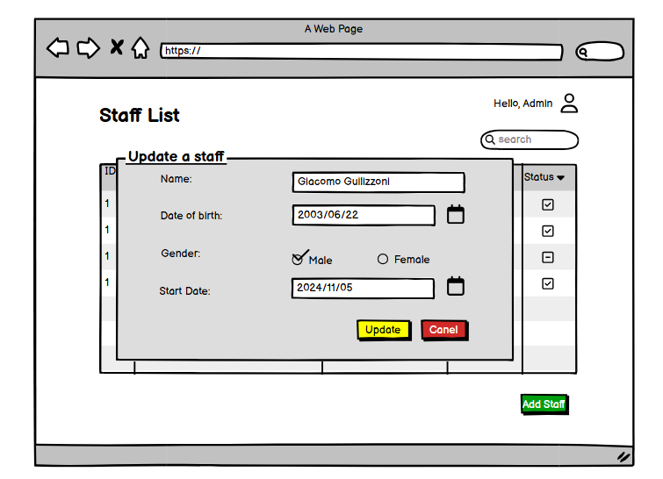

| **Screen** | | Staff Management - Update Staff | | | | |
| --- | --- | --- | --- | --- | --- | --- |
| **Description** | | | Allows the manager to edit and update the details of an existing staff member. Changes may include name, role, contact information, salary, or employment status. | | | |
| **Screen Access** | | | Navigate to **Staff Management -> View Staff -> Select Staff -> Update Staff** | | | |
| **Screen Content** | | | | | | |
| **Item** | | | **Type** | **Data** | | **Description** |
| Staff Name | | | Text field – String (50) | Pre-filled from database | | Enter the updated name of the staff member. |
| Date of Birth | | | Date | Pre-filled from database | | Update the staff member’s date of birth. |
| Gender | | | Dropdown – String | Pre-filled from database | | Update the gender of the staff member. |
| Phone Number | | | Text field – String (15) | Pre-filled from database | | Enter the updated contact number. |
| Address | | | Text field – String (100) | Pre-filled from database | | Enter the updated address of the staff member. |
| Salary | | | Text field – Number (10) | Pre-filled from database | | Update the salary of the staff member. |
| Status | | | Dropdown – String (Active/Inactive) | Pre-filled from database | | Update the employment status of the staff member. |
| **Screen Actions** | | | | | | |
| **Action Name** | **Description** | | | | **Success** | **Failure** |
| Save Changes | Saves the updated staff details to the system database. | | | | Displays a success message: "Staff details updated successfully." | * Shows an error message highlighting invalid or missing fields. |
| Cancel | Cancels the update and returns to the **View Staff** screen. | | | | Redirects to the **View Staff** page. | NA |

### Delete Staff

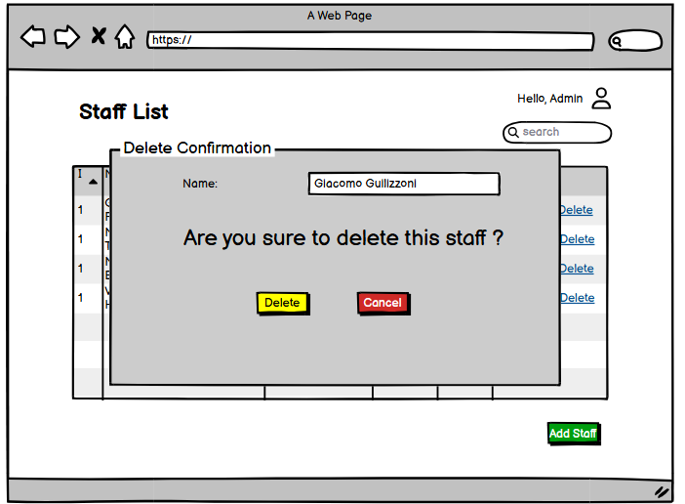

| **Screen** | Staff Management - Delete Staff | | | | |
| --- | --- | --- | --- | --- | --- |
| **Description** | | Allows the manager to permanently remove a staff member from the system database. Before deletion, the system prompts for confirmation to prevent accidental removal | | | |
| **Screen Access** | | Navigate to **Staff Management -> View Staff -> Select Staff -> Delete Staff** | | | |
| **Screen Content** | | | | | |
| **Item** | | **Type** | **Data** | | **Description** |
| Staff Name | | Label | Data retrieved from the database | | Displays the name of the staff member to confirm deletion. |
| Confirmation Message | | Text | Static content | | "Are you sure you want to delete this staff member?" |
| **Screen Actions** | | | | | |
| **Action Name** | | **Description** | | **Success** | **Failure** |
| Confirm Deletion | | Permanently deletes the staff member from the database. | | Displays message: "Staff member deleted successfully." | Displays an error: "Staff member has dependent tasks or relations." |
| Cancel | | Cancels the operation and returns to the **View Staff** screen. | | Redirects to the **View Staff** page | NA |

## 

## CRUD Inventory

| Use Case Name | CRUD Inventory |
| --- | --- |
| Use Case ID | UC09 |
| High Level Requirement Ref | The system must support all functionalities related to inventory management, including viewing inventory, adding new items, updating existing inventory records, and deleting items. |
| Actor | Manager |
| Description | Allows the manager to perform the following actions within the inventory module:   * View the current inventory list. * Add new inventory items. * Update details of existing inventory records. * Delete inventory items that are no longer needed |
| Trigger | The manager is logged into the system.  Necessary permissions for CRUD operations are granted. |
| Pre-condition | Quản lý đăng nhập vào hệ thống |
| Post-processing | The inventory list is updated to reflect changes.  Logs of all modifications (add, update, delete) are saved for audit purposes. |

### 

### Add Inventory

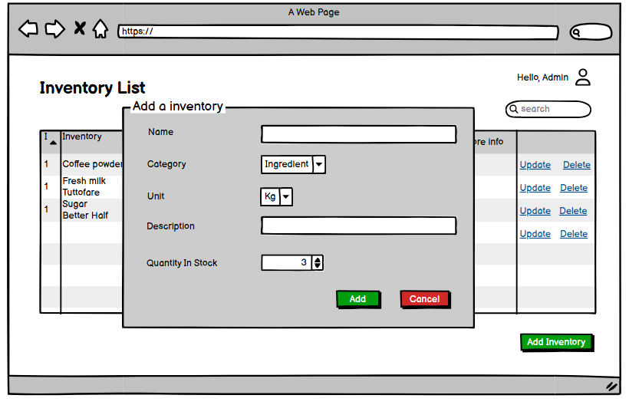

| **Screen** | Add Inventory | | | | |
| --- | --- | --- | --- | --- | --- |
| **Description** | | Enables the manager to add a new inventory item by entering details such as the item name, category, quantity, cost per unit, and expiration date | | | |
| **Screen Access** | | Navigate to **Inventory Management -> Add Inventory** | | | |
| **Screen Content** | | | | | |
| **Item** | | **Type** | **Data** | | **Description** |
| Item Name | | Text Field – String (50) | User Input | | The name of the inventory item. |
| Category | | Dropdown | Loaded from category | | Select or assign the category for the item |
| Quantity | | Button | User Input | | The number of items being added to the inventory. |
| Cost per Unit | | Text Field – Number | User Input | | The cost of one unit of the inventory item. |
| Expiration Date | | Date | User Input | | The date when the item will expire, if applicable. |
| **Screen Actions** | | | | | |
| **Action Name** | | **Description** | | **Success** | **Failure** |
| Add | | Save the new inventory item to the database. | | Displays a confirmation message: "Inventory item added." | Error message: "Failed to add item. Please check the input." |
| Cancel | | Clears all input fields and returns to the main inventory screen. | | Redirects back to the inventory list. | NA |

### View Inventory

| **Screen** | View Inventory | | | | |
| --- | --- | --- | --- | --- | --- |
| **Description** | | Allows the manager to view a detailed list of inventory items, including their names, categories, quantities, costs, and expiration dates. Provides filtering, sorting, and searching functionalities for easy navigation. | | | |
| **Screen Access** | | Navigate to **Inventory Management -> View Inventory**. | | | |
| **Screen Content** | | | | | |
| **Item** | | **Type** | **Data** | | **Description** |
| Search Bar | | Text Field | User Input | | Allows the manager to search inventory items by name or category. |
| **Screen Actions** | | | | | |
| **Action Name** | | **Description** | | **Success** | **Failure** |
| Search | | Filters the table based on input in the search bar. | | Displays matching inventory items in the table. | Shows an error if no items match the query. |

## 

### Update Inventory

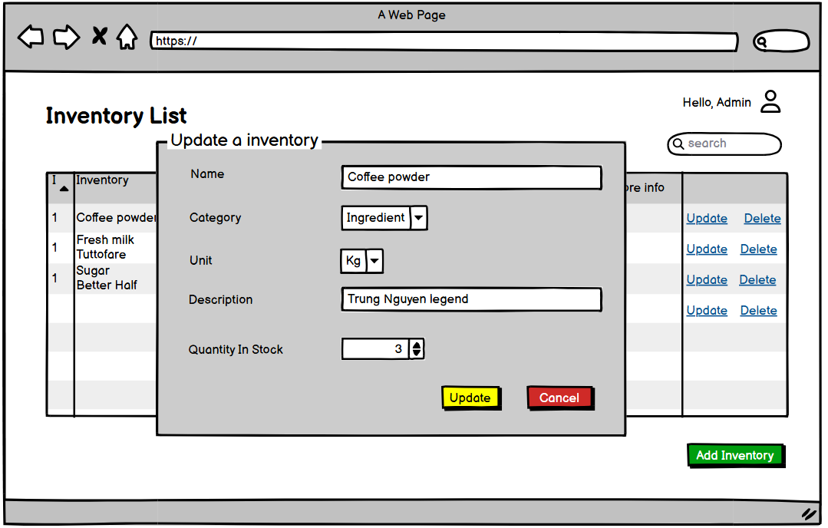

| **Screen** | Update Inventory | | | | |
| --- | --- | --- | --- | --- | --- |
| **Description** | | Enables the manager to update details of an existing inventory item, such as name, category, quantity, cost per unit, and expiration date. | | | |
| **Screen Access** | | Navigate to **Inventory Management -> Update Inventory**, or select an inventory item in the **View Inventory** screen and click the **Edit** button. | | | |
| **Screen Content** | | | | | |
| **Item** | | **Type** | **Data** | | **Description** |
| Item Name | | Text Field – String (50) | Pre-filled from database | | Allows the manager to search inventory items by name or category. |
| Category | | Text Field – Number | Pre-filled from database | | Allows selection or modification of the item's category. |
| Quantity | | Text Field – Number | Pre-filled from database | | Allows adjustment of the item's available stock. |
| Cost per Unit | | Text Field – Decimal | Pre-filled from database | | Allows adjustment of the item's per-unit price. |
| Expiration Date | | Date | Pre-filled from database | | Allows editing of the expiration date, if applicable. |
| Save Changes | | Button | Static | | Confirms updates to the item's details. |
| Cancel | | Button | Static | | Discards changes and returns to the **View Inventory** screen. |
| **Screen Actions** | | | | | |
| **Action Name** | | **Description** | | **Success** | **Failure** |
| Search | | Updates the item's details in the database. | | Confirmation message: *"Inventory item updated successfully."* | Error message: *"Failed to update. Please try again.* |
| Cancel | | Cancels the editing process and returns to the previous screen. | | Redirects back to the **View Inventory** screen. | NA |

## 

### Delete Inventory

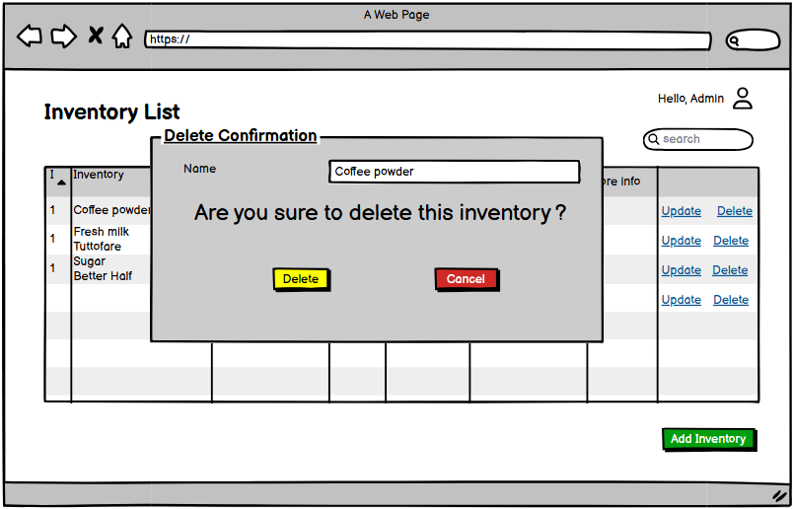

| **Screen** | Delete Inventory | | | | |
| --- | --- | --- | --- | --- | --- |
| **Description** | | Allows the manager to remove an inventory item from the system permanently. Includes options to confirm the deletion. | | | |
| **Screen Access** | | Navigate to *Inventory Management -> Delete Inventory*, or select an inventory item in the *View Inventory* screen and click the *Delete* button. | | | |
| **Screen Content** | | | | | |
| **Item** | | **Type** | **Data** | | **Description** |
| Item Name | | Text Field – String (50) | Pre-filled from database | | Displays the name of the selected inventory item. |
| Confirm | | Button | Static | | Confirms delete to the item's details. |
| Cancel | | Button | Static | | Discards delete and returns to the **View Inventory** screen. |
| **Screen Actions** | | | | | |
| **Action Name** | | **Description** | | **Success** | **Failure** |
| Confirm Delete | | Permanently removes the inventory item from the database after confirmation. | | Displays a success message: *Inventory item deleted successfully.* | Error message: *Failed to delete. Please try again.* |
| Cancel | | Cancels the deletion process and navigates back to the previous screen. | | Redirects to the *View Inventory* screen. | NA |

## 

## Export inventory data

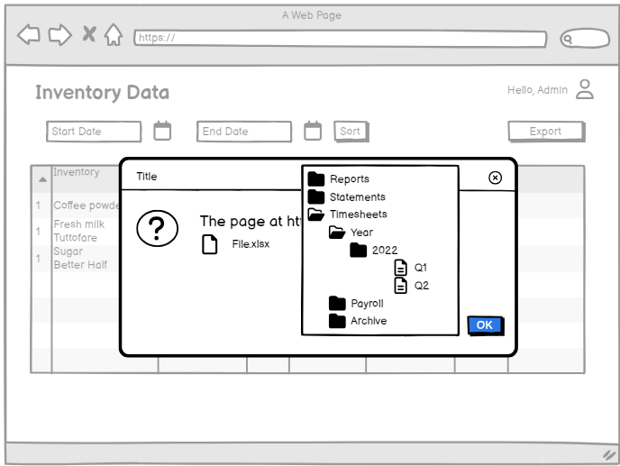

| Use Case Name | Export Inventory Data |
| --- | --- |
| Use Case ID | UC10 |
| High Level Requirement Ref | Allows the manager to perform data management tasks such as exporting or backing up inventory data. |
| Actor | Manager |
| Description | The manager can export inventory data for backup or reporting purposes. |
| Trigger | NA |
| Pre-condition | The manager must be logged into the system. |
| Post-processing | The exported file is generated and saved in the specified format (e.g., CSV or Excel). |

### 

| **Screen** | Export Inventory Data | | | | |
| --- | --- | --- | --- | --- | --- |
| **Description** | | Allows the manager to export inventory data into a file format of their choice (e.g., CSV, Excel) for backup, reporting, or sharing purposes. | | | |
| **Screen Access** | | Navigate to **Inventory Management -> Export Inventory**. | | | |
| **Screen Content** | | | | | |
| **Item** | | **Type** | **Data** | | **Description** |
| File Format | | Dropdown – Options: CSV, Excel | User Input | | Selects the format for the exported file. |
| Save Location | | File Picker |  | | Allows the manager to specify the location to save the exported file. |
| Export | | Button |  | | Starts the export process for the inventory data. |
| Cancel | | Button |  | | Cancels the operation and returns to the previous screen. |
| **Screen Actions** | | | | | |
| **Action Name** | | **Description** | | **Success** | **Failure** |
| Export | | Generates and saves the export file to the specified location. | | Success message: *"Inventory data exported successfully."* | Error message: *"Export failed. Please try again."* |
| Cancel | | Discards changes and returns to the previous screen. | | Redirects back to the previous screen. | NA |

## 

## CRUD Voucher

| Use Case Name | CRUD Voucher |
| --- | --- |
| Use Case ID | UC11 |
| High Level Requirement Ref | Allows the admin to perform CRUD (Create, Read, Update, Delete) operations on voucher records within the system. |
| Actor | Admin |
| Description | The admin can perform the following actions on voucher records:   * View a list of all vouchers, including details such as discount percentage, validity period, and usage limits. * Add new vouchers by entering required details (e.g. ,discount percentage, expiration date, etc.). * Update voucher details to reflect changes in discounts, validity, or usage limits. * Delete voucher records that are no longer valid or needed. |
| Trigger | The admin accesses the voucher management menu. |
| Pre-condition | The admin is logged into the system with proper credentials and permissions.  The system must display the voucher management interface. |
| Post-processing | Changes to voucher records are successfully saved in the system.  The updated list of vouchers reflects the changes immediately.  Notification or confirmation is provided for each action (e.g., "Voucher added successfully"). |

### View Voucher

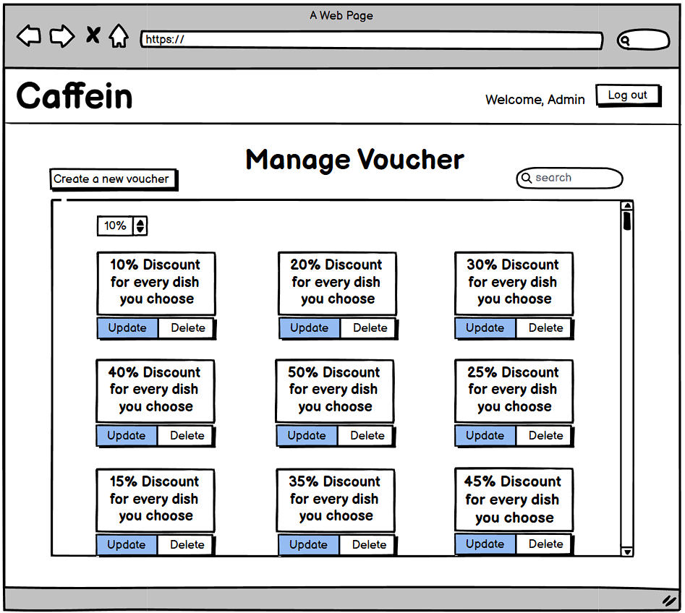

| **Screen** | View Voucher | | | | |
| --- | --- | --- | --- | --- | --- |
| **Description** | | Allows the admin to view a detailed list of voucher items, including discount and expiration dates. Provides filtering, sorting, and searching functionalities for easy navigation. | | | |
| **Screen Access** | | Navigate to **Voucher Management -> View Voucher**. | | | |
| **Screen Content** | | | | | |
| **Item** | | **Type** | **Data** | | **Description** |
| Search Bar | | Text field | Input by the admin | | Allows the admin to search voucher items by discount. |
| **Screen Actions** | | | | | |
| **Action Name** | | **Description** | | **Success** | **Failure** |
| View Details | | Displays all details for the selected voucher. | | Opens a detailed view page for the selected voucher. | N/A |
| Update Voucher | | Allows the admin to edit details of the selected voucher. | | Opens the edit voucher form for modifications. | Error: "Unable to load voucher details for editing." |
| Delete Voucher | | Removes the selected voucher member from the database. | | Displays confirmation: "Voucher deleted successfully." | Error: "Unable to delete voucher, dependent records exist." |

### Add Voucher

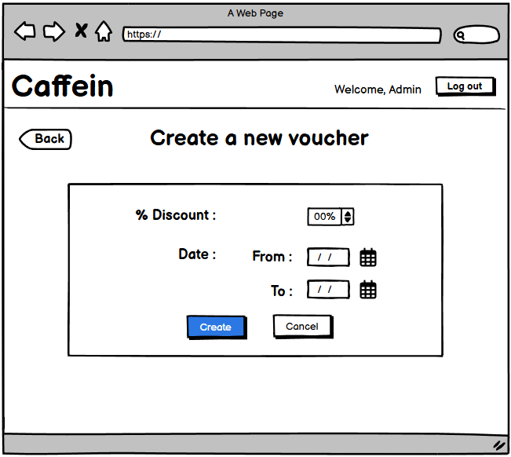

| **Screen** | VoucherManagement - Add A New Voucher | | | | |
| --- | --- | --- | --- | --- | --- |
| **Description** | | Allows the admin to add a new voucher items, including discount percent and expiration dates. | | | |
| **Screen Access** | | Navigate to **Voucher Management -> Create A New Voucher**. | | | |
| **Screen Content** | | | | | |
| **Item** | | **Type** | **Data** | | **Description** |
| Discount Percent | | Dropdown | Input by the admin | | The percent of discount. |
| Expiration Date | | Date | Input by the admin | | The date when the item will expire, if applicable. |
| **Screen Actions** | | | | | |
| **Action Name** | | **Description** | | **Success** | **Failure** |
| Create | | Save the new voucher item to the database. | | Displays a confirmation message: "Voucher added." | Error message: "Failed to create voucher. Please check the input." |
| Cancel | | Clears all input fields and returns to the main voucher screen. | | Redirects back to the voucher list. | N/A |

### Update Voucher

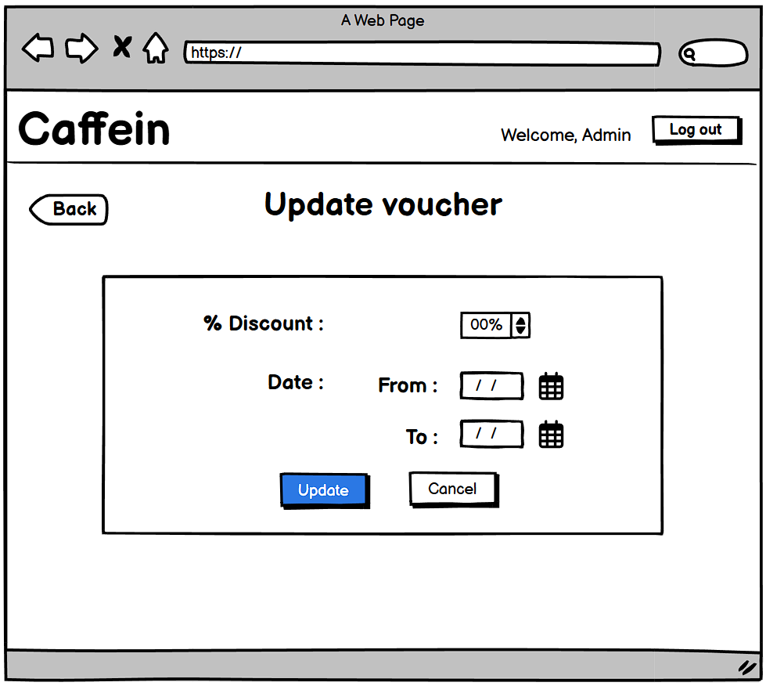

| **Screen** | VoucherManagement - Add A New Voucher | | | | |
| --- | --- | --- | --- | --- | --- |
| **Description** | | Allows the admin to update voucher items, including discount percent and expiration dates. | | | |
| **Screen Access** | | Navigate to **Voucher Management -> Update Voucher**. | | | |
| **Screen Content** | | | | | |
| **Item** | | **Type** | **Data** | | **Description** |
| Discount Percent | | Dropdown | Input by the admin | | The percent of discount. |
| Expiration Date | | Date | Input by the admin | | The date when the item will expire, if applicable. |
| **Screen Actions** | | | | | |
| **Action Name** | | **Description** | | **Success** | **Failure** |
| Update | | Save the new voucher item to the database. | | Displays a confirmation message: "Updated successfully." | Error message: "Failed to update voucher. Please check the input." |
| Cancel | | Clears all input fields and returns to the main voucher screen. | | Redirects back to the voucher list. | N/A |

### Delete Voucher

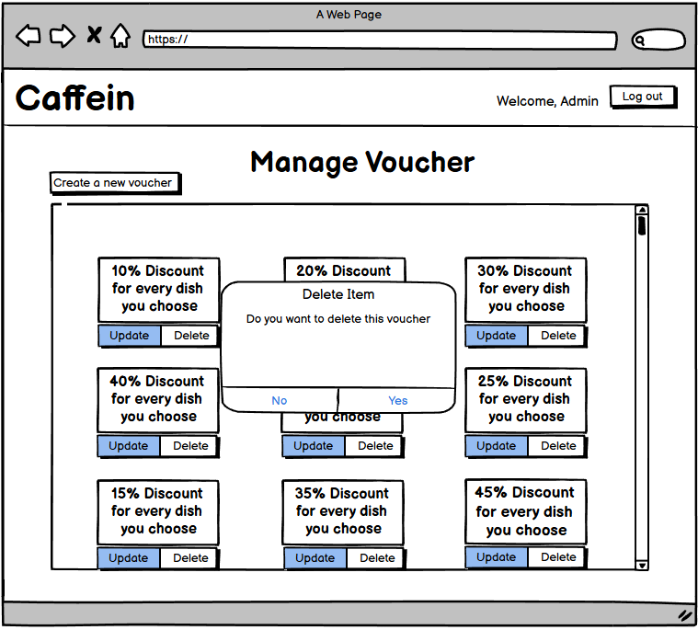

| **Screen** | Delete Voucher | | | | |
| --- | --- | --- | --- | --- | --- |
| **Description** | | Allows the admin to remove a voucher from the system permanently. Includes options to confirm the deletion. | | | |
| **Screen Access** | | Navigate to **Voucher Management -> View Voucher -> Select Voucher -> Delete** | | | |
| **Screen Content** | | | | | |
| **Item** | | **Type** | **Data** | | **Description** |
| Confirmation Message | | Text | Static content | | "Do you want to delete this voucher" |
| **Screen Actions** | | | | | |
| **Action Name** | | **Description** | | **Success** | **Failure** |
| Confirm Deletion | | Permanently deletes the voucher from the database. | | Displays message: "Voucher deleted successfully." | Displays an error: "Voucher has dependent tasks or relations." |
| Cancel | | Cancels the operation and returns to the **View Voucher** screen. | | Redirects to the **View Voucher** page | NA |

### 

## View revenue

| Use Case Name | View Revenue |
| --- | --- |
| Use Case ID | UC12 |
| High Level Requirement Ref | Allows the manager to generate statistics and reports. |
| Actor | Manager |
| Description | The manager can view revenue by selecting a specific time range and report criteria. |
| Trigger | NA |
| Pre-condition | The manager must be logged into the system |
| Post-processing | Revenue data is displayed based on the selected time range and criteria |

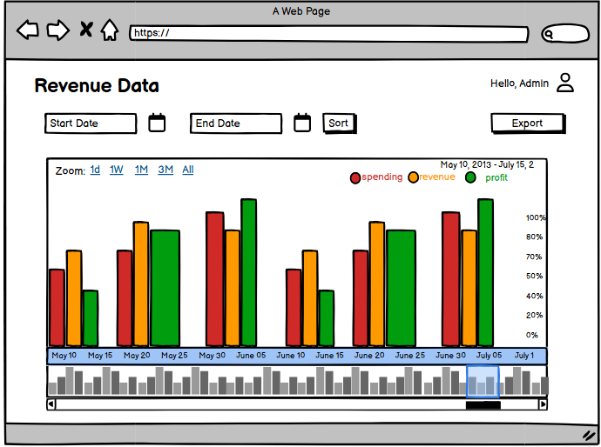

| **Screen** | View Revenue | | | | |
| --- | --- | --- | --- | --- | --- |
| **Description** | | Allows the manager to view revenue statistics within a specified time range and optionally filter by category or product. | | | |
| **Screen Access** | | Navigate to **Statistics and Reports -> View Revenue**. | | | |
| **Screen Content** | | | | | |
| **Item** | | **Type** | **Data** | | **Description** |
| From Date | | Date | User Input | | Specify the start date for revenue statistics. |
| To Date | | Date | User Input | | Specify the end date for revenue statistics. |
| Filter By | | Dropdown (Category/Product) |  | | Select criteria to filter revenue data. |
| **Screen Actions** | | | | | |
| **Action Name** | | **Description** | | **Success** | **Failure** |
| View revenue | | Fetch and display revenue data based on selected criteria. | | Display data results on the table | NA |

## 

## Export revenue data

| Use Case Name | Export Revenue Data |
| --- | --- |
| Use Case ID | UC13 |
| High Level Requirement Ref | Allows the manager to export revenue data for external use. |
| Actor | Manager |
| Description | Enables the manager to export revenue data based on selected time periods or filter criteria. |
| Trigger | The manager clicks on the "Export Data" button. |
| Pre-condition | The manager is logged in and has accessed the revenue statistics screen. |
| Post-processing | A revenue data file is downloaded in the selected format (CSV or Excel). |

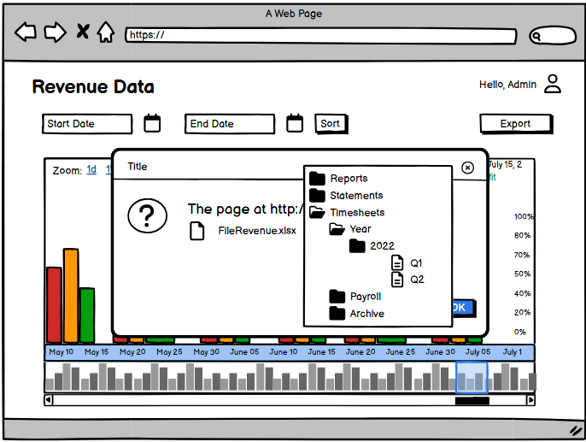

| **Screen** | Export Revenue Data | | | | |
| --- | --- | --- | --- | --- | --- |
| **Description** | | Allows the manager to export filtered revenue data for the desired time range | | | |
| **Screen Access** | | Navigate to **Statistics and Reports -> Export Revenue Data**. | | | |
| **Screen Content** | | | | | |
| **Item** | | **Type** | **Data** | | **Description** |
| From Date | | Date | User Input | | Specify the start date for revenue statistics. |
| To Date | | Date | User Input | | Specify the end date for revenue statistics. |
| File Format | | Dropdown (Category/Product) | CSV, Excel | | Select export format. Default: Excel. |
| **Screen Actions** | | | | | |
| **Action Name** | | **Description** | | **Success** | **Failure** |
| Export Data | | Exports filtered revenue data as a downloadable file in the selected format. | | Success message: *"Export completed. File downloaded successfully."* | Error message: *"Export failed. Please verify your inputs and try again."* |
| Cancel | | Discards any input and returns to the previous screen. | | Returns to the previous screen. | NA |

# **YÊU CẦU PHI CHỨC NĂNG VÀ YÊU CẦU KHÁC**

Efficiency

| **Mã.** | **Yêu cầu** |
| --- | --- |
| 1. | Takes up little computer resources |
| 2. | Fast response speed, small time out |

Security

| **Mã.** | **Yêu cầu** |
| --- | --- |
| 1. | Authentication |
| 2. | Authorization |
| 3. |  |

Hardware

| **Mã.** | **Requirement** |
| --- | --- |
| 1. | Ram 512MB, HDD 2GB, chip Intel Pentium 4 1.7GHz |

Internet

| **Mã.** | **Requirement** |
| --- | --- |
| 1. | Have internet access |

Reliability

| **Mã.** | **Requirement** |
| --- | --- |
| 1. | The results are accurate, complete, and concise |

User Interface

| **Mã.** | **Requirement** |
| --- | --- |
| 1. | Friendly interface, clear, simple, easy to understand and easy to use |

Scalability

| **Mã.** | **Requirement** |
| --- | --- |
| 1. | Back up data to the server. |

# APPENDIX